horizontal line

INFO 350

Match-Maker App

## Analysis & Design

**April 23, 2018**

# OVERVIEW (The Problem)

The problem is we want to create an application that will match the user based on their results to the profile of a person, thus making them a ‘match’. The user would be asked questions that would eliminate other candidates with each question, leaving either a perfect match or no match at all.

# Table with Variables and Constants

# Variables

|  |  |  |
| --- | --- | --- |
| **Data type** | **Identifier** | **Range** |
| string | sex | 0 or 1 |
| string | age | Any int |
| string | occupation | 0 or 1 |
| string | hobbies | 0 or 1 |
| string | peeves | 0 or 1 |

# Constant

|  |  |  |
| --- | --- | --- |
| **Data Type** | **Identifier** | **Value** |
| double | sex | s |
| double | age | a |
| double | occupation | o |
| double | hobbies | h |
| double | peeves | p |

# Classes

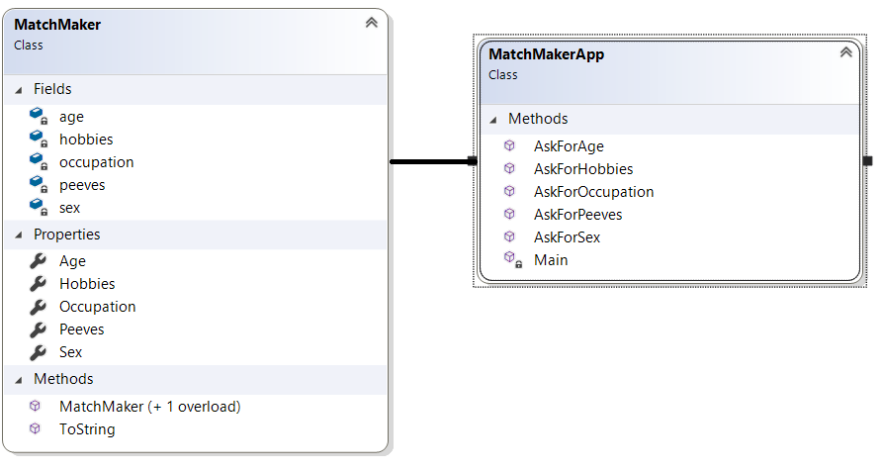

# Prototype of Console Window

If you match with someone:

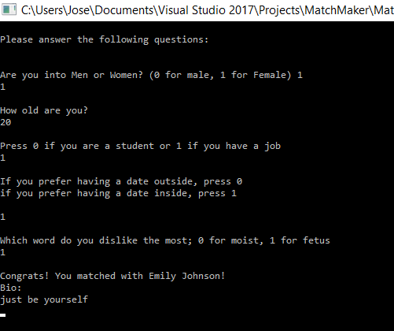

If you don’t match with someone:

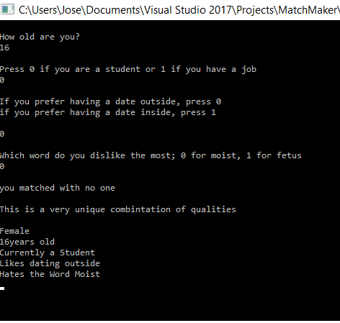

# Decision Tree

To help someone find their match on a dating application

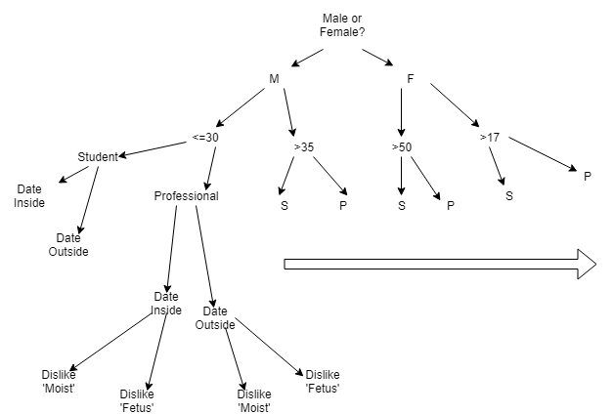

# Pseudocode

Algorithm

To create a user profile in an effort to match a user to possible candidates.

---

BEGIN

Input value in Male, Female

s = input value

If s = M

then Male

Else

Female

Output s

Input value in age

a=input value

Output a

Input value in occupation

o=input value

If o=0

Then occupation is Student

Else

Then occupation is job

Output o

Input value in hobbies

h=input value

If h=0

Then hobby is “likes dating outside”

Else

Then hobby is “likes dating inside”

Output h

Input value in peeves

p=input value

If p=0

Then peeve is “hates the word moist”

Else

Then peeve is “hates the word fetus”

Output p

END

# 

# Class Diagram

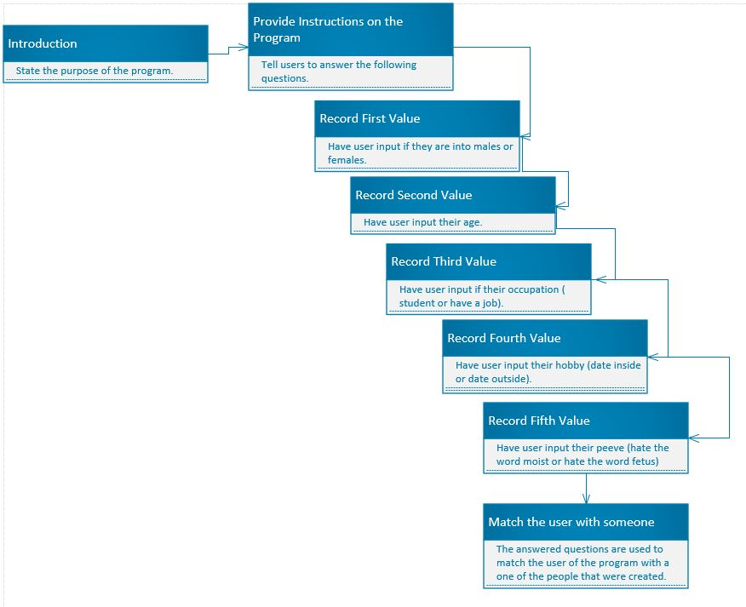

**Flowchart**

